ASR 6978 Daily outbound summary

Date 2018.03.07

**Request 4: Daily outbound summary, to have auto remark updates for SOLI consist split request (Indicate as split lot)**

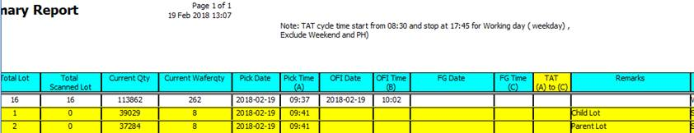

Split lot logic – if SOLI (SCH_OFI_OUTBOUND_SO_LOT) consist Split request , either Parent lot id or child lot ID.

**Splitlot** = (select COUNT(1) from SCH_OFI_SPLIT_REQUEST

where ChildLotID = SCH_OFI_OUTBOUND_SO_LOT.LotID

OR ParentLotID = SCH_OFI_OUTBOUND_SO_LOT.LotID ) > 0 THEN “Split Lot” Else “” END

Change on current Remarks field in report:

= **Splitlot** + Remarks

[2018.03.16]

SQL- Use subquery

, Remarks = CASE WHEN ( ( Select COUNT(SR.childlotid) FROM SCH_OFI_OUTBOUND_SO_LOT A

Left Outer join SCH_OFI_SPLIT_REQUEST SR ON ( SR.ParentLotID = a.LotID or SR.ChildLotID = a.LotID ) WHERE A.ImportNo = i.ImportNo

AND A.SO = i.SO and A.lineitem = i.lineitem )

) > 0

THEN 'Split Lot ' ELSE '' END + MAX(i.Remarks)

Updated Report [2018.03.16]

